The laboratory work 9

Defining Calculations
Calculated members are members of a dimension or a measure group that are defined based on a combination of cube data, arithmetic operators, numbers, and functions. For example, you can create a calculated member that calculates the sum of two physical measures in the cube. Calculated member definitions are stored in cubes, but their values are calculated at query time.
To create a calculated member, use the New Calculated Member command on the Calculations tab of Cube Designer. You can create a calculated member within any dimension, including the measures dimension. You can also place a calculated member within a display folder in the Calculation Properties dialog box. For more information, see Calculations, Calculations in Multidimensional Models, and Create Calculated Members.
In the tasks in this topic, you define calculated measures to let users view the gross profit margin percentage and sales ratios for Internet sales, reseller sales, and for all sales.

Defining Calculations to Aggregate Physical Measures

- Open Cube Designer for the Analysis Services Tutorial cube, and then click the Calculations tab.
Notice the default CALCULATE command in the Calculation Expressions pane and in the Script Organizer pane. This command specifies that the measures in the cube should be aggregated according to the value that is specified by their AggregateFunction properties. Measure values are generally summed, but may also be counted or aggregated in some other manner.
The following image shows the Calculations tab of Cube Designer.
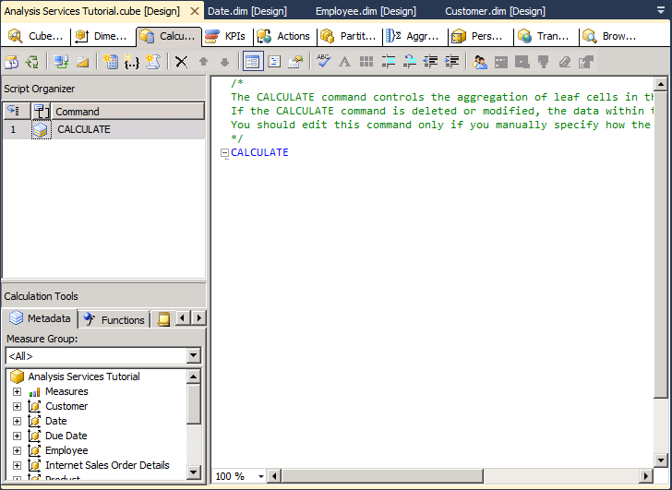
- On the toolbar of the Calculations tab, click New Calculated Member.
A new form appears in the Calculation Expressions pane within which you define the properties of this new calculated member. The new member also appears in the Script Organizer pane.
The following image shows the form that appears in the Calculation Expressions pane when you click New Calculated Member.
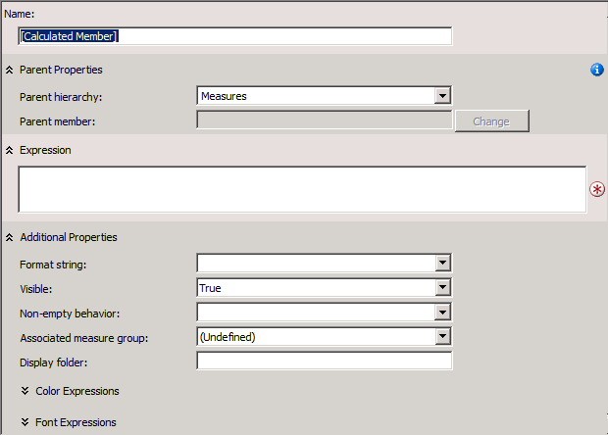
- In the Name box, change the name of the calculated measure to [Total Sales Amount].
If the name of a calculated member contains a space, the calculated member name must be enclosed in square brackets.
Notice in the Parent hierarchy list that, by default, a new calculated member is created in the Measures dimension. A calculated member in the Measures dimension is also frequently called a calculated measure.
- On the Metadata tab in the Calculation Tools pane of the Calculations tab, expand Measures and then expand Internet Sales to view the metadata for the Internet Sales measure group.
You can drag metadata elements from the Calculation Tools pane into the Expression box and then add operators and other elements to create Multidimensional Expressions (MDX) expressions. Alternatively, you can type the MDX expression directly into the Expression box.
Note
If you cannot view any metadata in the Calculation Tools pane, click Reconnect on the toolbar. If this does not work, you may have to process the cube or start the instance of Analysis Services.
- Drag Internet Sales-Sales Amount from the Metadata tab in the Calculation Tools pane into the Expression box in the Calculation Expressions pane.
- In the Expression box, type a plus sign (+) after [Measures].[Internet Sales-Sales Amount].
- On the Metadata tab in the Calculation Tools pane, expand Reseller Sales, and then drag Reseller Sales-Sales Amount into the Expression box in the Calculation Expressions pane after the plus sign (+).
- In the Format string list, select "Currency".
- In the Non-empty behavior list, select the check boxes for Internet Sales-Sales Amount and Reseller Sales-Sales Amount, and then click OK.
The measures you specify in the Non-empty behavior list are used to resolve NON EMPTY queries in MDX. When you specify one or more measures in the Non-empty behavior list, Analysis Services treats the calculated member as empty if all the specified measures are empty. If the Non-empty behavior property is blank, Analysis Services must evaluate the calculated member itself to determine whether the member is empty.
The following image shows the Calculation Expressions pane populated with the settings that you specified in the previous steps.
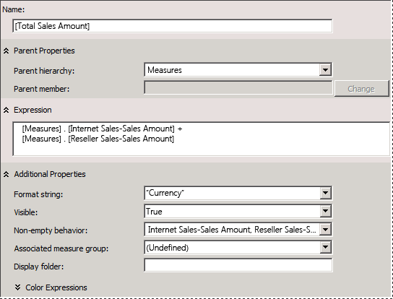
- On the toolbar of the Calculations tab, click Script View, and then review the calculation script in the Calculation Expressions pane.
Notice that the new calculation is added to the initial CALCULATE expression; each individual calculation is separated by a semicolon. Notice also that a comment appears at the beginning of the calculation script. Adding comments within the calculation script for groups of calculations is a good practice, to help you and other developers understand complex calculation scripts.
- Add a new line in the calculation script after the Calculate; command and before the newly added calculation script, and then add the following text to the script on its own line:
/* Calculations to aggregate Internet Sales and Reseller Sales measures */
The following image shows the calculation scripts as they should appear in the Calculation Expressions pane at this point in the tutorial.
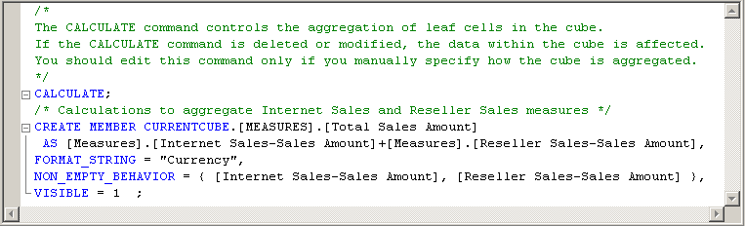
On the toolbar of the Calculations tab, click Form View, verify that [Total Sales Amount] is selected in the Script Organizer pane, and then click New Calculated Member.
Change the name of this new calculated member to [Total Product Cost], and then create the following expression in the Expression box:
[Measures].[Internet Sales-Total Product Cost] + [Measures].[Reseller Sales-Total Product Cost]
In the Format string list, select "Currency".
In the Non-empty behavior list, select the check boxes for Internet Sales-Total Product Cost and Reseller Sales-Total Product Cost, and then click OK.
You have now defined two calculated members, both of which are visible in the Script Organizer pane. These calculated members can be used by other calculations that you define later in the calculation script. You can view the definition of any calculated member by selecting the calculated member in the Script Organizer pane; the definition of the calculated member will appear in the Calculation Expressions pane in the Form view. Newly defined calculated members will not appear in the Calculation Tools pane until these objects have been deployed. Calculations do not require processing.

Defining Gross Profit Margin Calculations
- Verify that [Total Product Cost] is selected in the Script Organizer pane, and then click New Calculated Member on the toolbar of the Calculations tab.
- In the Name box, change the name of this new calculated measure to [Internet GPM].
- In the Expression box, create the following MDX expression:
([Measures].[Internet Sales-Sales Amount] -
[Measures].[Internet Sales-Total Product Cost]) /
[Measures].[Internet Sales-Sales Amount]
In the Format string list, select "Percent".
In the Non-empty behavior list, select the check box for Internet Sales-Sales Amount, and then click OK.
On the toolbar of the Calculations tab, click New Calculated Member.
In the Name box, change the name of this new calculated measure to [Reseller GPM].
In the Expression box, create the following MDX expression:
([Measures].[Reseller Sales-Sales Amount] -
[Measures].[Reseller Sales-Total Product Cost]) /
[Measures].[Reseller Sales-Sales Amount]
In the Format string list, select "Percent".
In the Non-empty behavior list, select the check box for Reseller Sales-Sales Amount, and then click OK.
On the toolbar of the Calculations tab, click New Calculated Member.
In the Name box, change the name of this calculated measure to [Total GPM].
In the Expression box, create the following MDX expression:
([Measures].[Total Sales Amount] -
[Measures].[Total Product Cost]) /
[Measures].[Total Sales Amount]
Notice that this calculated member is referencing other calculated members. Because this calculated member will be calculated after the calculated members that it references, this is a valid calculated member.
In the Format string list, select "Percent".
In the Non-empty behavior list, select the check boxes for Internet Sales-Sales Amount and Reseller Sales-Sales Amount, and then click OK.
On the toolbar of the Calculations tab, click Script View and review the three calculations you just added to the calculation script.
Add a new line in the calculation script immediately before the [Internet GPM] calculation, and then add the following text to the script on its own line:
- /* Calculations to calculate gross profit margin */
- The following image shows the Expressions pane with the three new calculations.
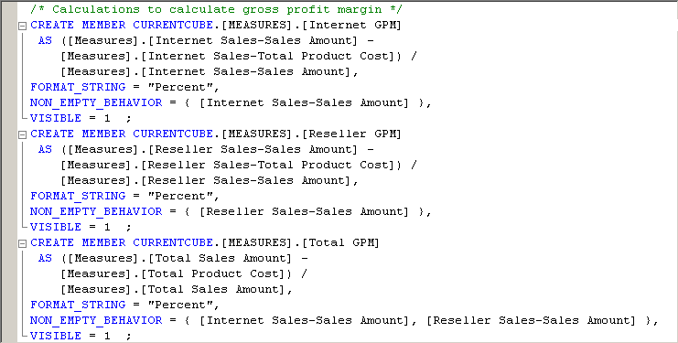

Defining the Percent of Total Calculations
- On the toolbar of the Calculations tab, click Form View.
- In the Script Organizer pane, select [Total GPM], and then click New Calculated Member on the toolbar of the Calculations tab.
Clicking the final calculated member in the Script Organizer pane before you click New Calculated Member guarantees that the new calculated member will be entered at the end of the script. Scripts execute in the order that they appear in the Script Organizer pane.
- Change the name of this new calculated member to [Internet Sales Ratio to All Products].
- Type the following expression in the Expression box:
Case
When IsEmpty( [Measures].[Internet Sales-Sales Amount] )
Then 0
Else ( [Product].[Product Categories].CurrentMember,
[Measures].[Internet Sales-Sales Amount]) /
( [Product].[Product Categories].[(All)].[All],
[Measures].[Internet Sales-Sales Amount] )
End
This MDX expression calculates the contribution to total Internet sales of each product. The Case statement together with the IS EMPTY function ensures that a divide by zero error does not occur when a product has no sales.
In the Format string list, select "Percent".
In the Non-empty behavior list, select the check box for Internet Sales-Sales Amount, and then click OK.
On the toolbar of the Calculations tab, click New Calculated Member.
Change the name of this calculated member to [Reseller Sales Ratio to All Products].
Type the following expression in the Expression box:
Case
When IsEmpty( [Measures].[Reseller Sales-Sales Amount] )
Then 0
Else ( [Product].[Product Categories].CurrentMember,
[Measures].[Reseller Sales-Sales Amount]) /
( [Product].[Product Categories].[(All)].[All],
[Measures].[Reseller Sales-Sales Amount] )
End
In the Format string list, select "Percent".
In the Non-empty behavior list, select the check box for Reseller Sales-Sales Amount, and then click OK.
On the toolbar of the Calculations tab, click New Calculated Member.
Change the name of this calculated member to [Total Sales Ratio to All Products].
Type the following expression in the Expression box:
Case
When IsEmpty( [Measures].[Total Sales Amount] )
Then 0
Else ( [Product].[Product Categories].CurrentMember,
[Measures].[Total Sales Amount]) /
( [Product].[Product Categories].[(All)].[All],
[Measures].[Total Sales Amount] )
End
In the Format string list, select "Percent".
In the Non-empty behavior list, select the check boxes for Internet Sales-Sales Amount and Reseller Sales-Sales Amount, and then click OK.
On the toolbar of the Calculations tab, click Script View, and then review the three calculations that you just added to the calculation script.
Add a new line in the calculation script immediately before the [Internet Sales Ratio to All Products] calculation, and then add the following text to the script on its own line:
- /* Calculations to calculate percentage of product to total product sales */
- You have now defined a total of eight calculated members, which are visible in the Script Organizer pane when you are in Form view.

Browsing the New Calculated Members
- On the Build menu of SQL Server Data Tools, click Deploy Analysis Services Tutorial.
- When deployment has successfully completed, switch to the Browser tab, click Reconnect.
- Click the Excel icon, and then click Enable.
- In the PivotTable Field List pane, expand Values folder to view the new calculated members in the Measures dimension.
- Drag the Total Sales Amount to the Values area, and then review the results.
Drag Internet Sales-Sales Amount and Reseller Sales-Sales Amount measures from the Internet Sales and Reseller Sales measure groups to the Values area.
Notice that the Total Sales Amount measure is the sum of the Internet Sales-Sales Amount measure and the Reseller Sales-Sales Amount measure.
- Add the Product Categories user-defined hierarchy to the filter area of the Report Filter area, and then filter the data by Mountain Bikes.
Notice that the Total Sales Amount measure is calculated for the Mountain Bikes category of product sales based on the Internet Sales-Sales Amount and the Reseller Sales-Sales Amount measures for Mountain Bikes.
- Add the Date.Calendar Date user-defined hierarchy to the Row labels area, and then review the results.
Notice that the Total Sales Amount measure for each calendar year is calculated for the Mountain Bikes category of product sales based on the Internet Sales-Sales Amount and the Reseller Sales-Sales Amount measures for Mountain Bikes.
- Add the Total GPM, Internet GPM, and Reseller GPM measures to the Values area, and then review the results.
Notice that the gross profit margin for reseller sales is significantly lower than for sales over the Internet, as shown in the following image.
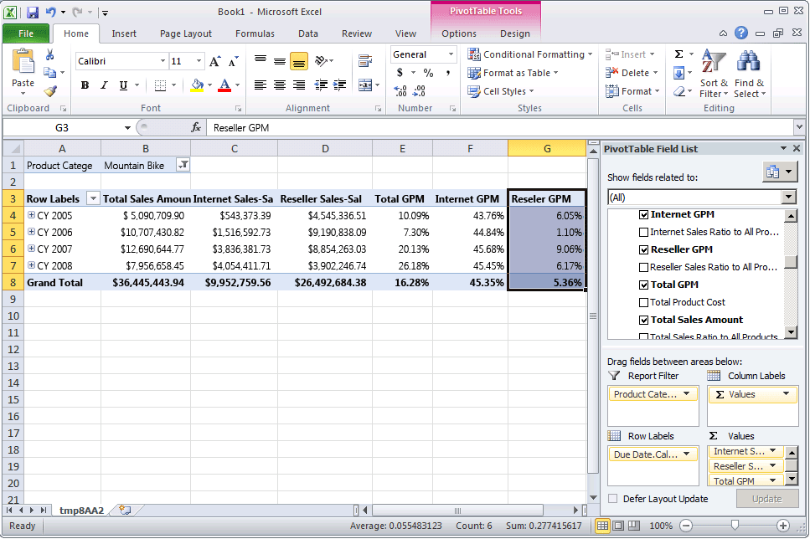
- Add the Total Sales Ratio to All Products, Internet Sales Ratio to All Products, and Reseller Sales Ratio to All Products measures to the Values area.
Notice that the ratio of the sales of mountain bikes to all products has increased over time for Internet sales, but is decreasing over time for reseller sales. Notice also that the ratio of the sale of mountain bikes to all products is lower from sales through resellers than it is for sales over the Internet.
- Change the filter from Mountain Bikes to Bikes, and review the results.
Notice that the gross profit margin for all bikes sold through resellers is negative, because touring bikes and road bikes are being sold at a loss.
- Change the filter to Accessories, and then review the results.
Notice that the sale of accessories is increasing over time, but that these sales make up only a small fraction of total sales. Notice also that the gross profit margin for sales of accessories is higher than for bikes.
A named set is a Multidimensional Expressions (MDX) expression that returns a set of dimension members. You can define named sets and save them as part of the cube definition; you can also create named sets in client applications. You create named sets by combining cube data, arithmetic operators, numbers, and functions. Named sets can be used by users in MDX queries in client applications and can also be used to define sets in subcubes. A subcube is a collection of crossjoined sets that restricts the cube space to the defined subspace for subsequent statements. Defining a restricted cube space is a fundamental concept to MDX scripting.
Named sets simplify MDX queries and provide useful aliases for complex, typically used, set expressions. For example, you can define a named set called Large Resellers that contains the set of members in the Reseller dimension that have the most employees. End users could then use the Large Resellers named set in queries, or you could use the named set to define a set in a subcube. Named set definitions are stored in cubes, but their values exist only in memory. To create a named set, use the New Named Set command on the Calculations tab of Cube Designer. For more information, see Calculations, Create Named Sets.
In the tasks in this topic, you will define two named sets: a Core Products named set and a Large Resellers named set.

Defining a Core Products Named Set
- Switch to the Calculations tab of Cube Designer for the Analysis Services Tutorial cube, and then click Form View on the toolbar.
- Click [Total Sales Ratio to All Products] in the Script Organizer pane, and then click New Named Set on the toolbar of the Calculations tab.
When you define a new calculation on the Calculations tab, remember that calculations are resolved in the order in which they appear in the Script Organizer pane. Your focus within that pane when you create a new calculation determines the order of the execution of the calculation; a new calculation is defined immediately after the calculation on which you are focused.
- In the Name box, change the name of the new named set to [Core Products].
In the Script Organizer pane, notice the unique icon that differentiates a named set from a script command or a calculated member.
- On the Metadata tab in the Calculation Tools pane, expand Product, expand Category, expand Members, and then expand All Products.
Note
If you cannot view any metadata in the Calculation Tools pane, click Reconnect on the toolbar. If this does not work, you may have to process the cube or start the instance of Analysis Services.
- Drag Bikes into the Expression box.
You now have created a set expression that will return the set of members that are in the Bike category in the Product dimension.

Defining a Large Resellers Named Set
- Right-click [Core Products] in the Script Organizer pane, and then click New Named Set.
- In the Name box, change the name of this named set to [Large Resellers].
- In the Expression box, type Exists().
You will use the Exists function to return the set of members from the Reseller Name attribute hierarchy that intersects with the set of members in the Number of Employees attribute hierarchy that has the largest number of employees.
- On the Metadata tab in the Calculation Tools pane, expand the Reseller dimension, and then expand the Reseller Name attribute hierarchy.
- Drag the Reseller Name level into the parenthesis for the Exists set expression.
You will use the Members function to return all members of this set. For more information, see Members (Set) (MDX).
- After the partial set expression, type a period, and then add the Members function. Your expression should look like the following:
Exists([Reseller].[Reseller Name].[Reseller Name].Members)
Now that you have defined the first set for the Exists set expression, you are ready to add the second set-the set of members of the Reseller dimension that contains the largest number of employees.
On the Metadata tab in the Calculation Tools pane, expand Number of Employees in the Reseller dimension, expand Members, and then expand All Resellers.
Notice that the members of this attribute hierarchy are not grouped.
Open Dimension Designer for the Reseller dimension, and then click Number of Employees in the Attributes pane.
In the Properties window, change the DiscretizationMethod property to Automatic, and then change the DiscretizationBucketCount property to 5. For more information, see Group Attribute Members (Discretization).
On the Build menu of SQL Server Data Tools, click Deploy Analysis Services Tutorial.
When deployment has successfully completed, switch to Cube Designer for the Analysis Services Tutorial cube, and then click Reconnect on the toolbar of the Calculations tab.
On the Metadata tab in the Calculation Tools pane, expand Number of Employees in the Reseller dimension, expand Members, and then expand All Resellers.
Notice that the members of this attribute hierarchy are now contained in five groups, numbered 0 through 4. To view the number of a group, pause the pointer over that group to view an InfoTip. For the range 2 -17, the InfoTip should contain [Reseller].[Number of Employees].&[0].
The members of this attribute hierarchy are grouped because the DiscretizationBucketCount property is set to 5 and the DiscretizationMethod property is set to Automatic.
In the Expression box, add a comma in the Exists set expression after the Members function and before the closing parenthesis, and then drag 83 - 100 from the Metadata pane and position it after the comma.
You have now completed the Exists set expression that will return the set of members that intersects with these two specified sets, the set of all resellers and the set of resellers who have 83 to 100 employees, when the Large Resellers named set is put on an axis.
The following image shows the Calculation Expressions pane for the [Large Resellers] named set.
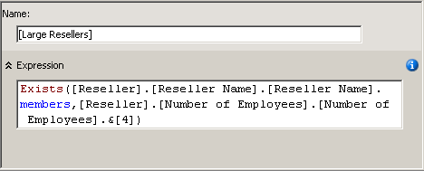
On the toolbar of the Calculations tab, click Script View, and then review the two named sets that you have just added to the calculation script.
Add a new line in the calculation script immediately before the first CREATE SET command, and then add the following text to the script on its own line:
- /* named sets */
- You have now defined two named sets, which are visible in the Script Organizer pane. You are now ready to deploy these named sets, and then to browse these measures in the Analysis Services Tutorial cube.

Browsing the Cube by Using the New Named Sets
- On the Build menu of SQL Server Data Tools, click Deploy Analysis Services Tutorial.
- When deployment has successfully completed, click the Browser tab, and then click Reconnect.
- Clear the grid in the data pane.
- Add the Reseller Sales-Sales Amount measure to the data area.
- Expand the Product dimension, and then add Category and Subcategory to the row area, as shown in the following image.
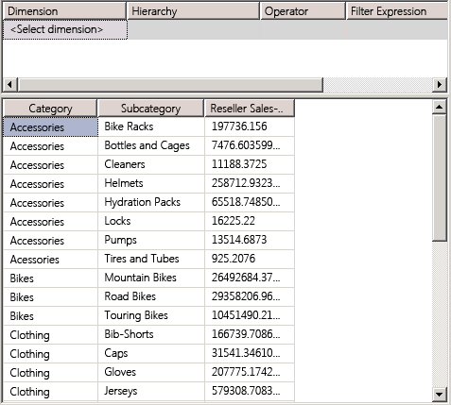
- In the Metadata pane, in the Product dimension, drag Core Products to the filter area.
Notice that only the Bike member of the Category attribute and members of the Bike subcategories remain in the cube. This is because the Core Products named set is used to define a subcube. This subcube limits the members of the Category attribute in the Product dimension within the subcube to those members of the Core Product named set, as shown in the following image.
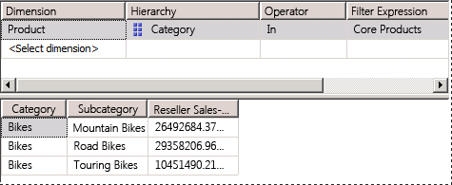
- In the Metadata pane, expand Reseller, add Large Resellers to the filter area.
Notice that the Reseller Sales Amount measure in the Data pane only displays sales amounts for large resellers of bikes. Notice also that the Filter pane now displays the two named sets that are used to define this particular subcube, as shown in the following image.
